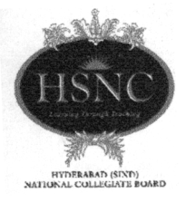

Principal K. M. Kundnani Pharmacy Polytechnic

[GOVERNMENT AIDED]
CHM CAMPUS, OPP. RAILWAY STATION, SMT. CHANDIBAI HIMATHMAL MANSUKHANI ROAD,
ULHASNAGAR-421 003 (Dist. Thane), Maharashtra State
Managed by: Hyderabad (Sind) National Collegiate Board, Mumbai
Tel. : 0251-2705163 E-mail : pkmkpp2003@yahoo.com,
Website: www.pkmkpp.org

----------------------------------------------------------------------------------------------------------------------
Ref :LIB-BOOK/2022-23/ Date : 17/10/2022

To,

Sub: Quotation for Indian Pharmacopoeia 2022
Sir,

Please send the lowest quotation for the Indian Pharmacopoeia 2022 (9th edition) By IPC on or before 01/11/2022

Mrs. Manjiri S. Gharat
I/c Principal

Terms & Conditions:

- Quotation should address to I/c Principal, Prin. K. M. Kundnani Pharmacy Polytechnic, Ulhasnagar -3 in a sealed envelope and acknowledgment should be collected.
- Submit quotation on or before 01/11/2022, after which quotation will not be accepted.
- Mention Payment and Delivery conditions.
- Mention if the rates are inclusive of appropriate GST.

